MMFA: Updated Technical Bulletin “Underlays”

EN 16354 and new MMF product categories now incorporated

The new European product standard EN 16354:2018 has superseded the previous Technical Specification CEN/TS 16354. For this reason, the MMFA is publishing an updated version of its Technical Bulletin covering underlay materials. The new document can be downloaded free of charge in PDF form from the homepage of the Association’s website www.mmfa.eu. Language versions currently available are German and English, but French and Dutch will be added shortly.

In many cases, the correct choice of underlay is crucial to allow a floor covering system to perform without damage. Since it was published in 2014, the MMFA’s Technical Bulletin “Underlay Materials under Multilayer Modular Floor Coverings (MMF) – Test Standards and Performance Indicators” has given practical advice and specific recommendations. The new edition dated 08/2019 is in line with the current status of product standardisation, research and development, taking into account the new EN 16354:2018 (Laminate floor coverings - Underlays - Specifications, requirements and test methods) and likewise the updated classification system for the MMFA product categories “Wood – Polymer – Mixed”.

Included as an annexe to the MMFA bulletin are two overview tables clearly summarising the underlay requirements for the different MMF products both with and without HDF core. Product structures under the MMFA’s “Wood” category with HDF core have underlay requirements which are very similar to those for laminate flooring. Here the minimum CS value (compressive strength) of the underlay is 10 kPa, and for heavier duty it is minimum 60 kPa. Products in the MMFA’s “Polymer” and “Mixed” categories have very different requirements – to avoid damage, these floor coverings require underlay materials with high compressive strength. The CS value of the underlay for these should be minimum 200 kPa, and for heavier duty it should be at least 400 kPa.

The purpose of the MMFA Technical Bulletins is to provide generally valid, non-company-specific guidelines and recommendations for the different product groups. Any interested specialists and users can download the files free of charge from the Association’s website www.mmfa.eu.
www.mmfa.eu

Image
Image caption
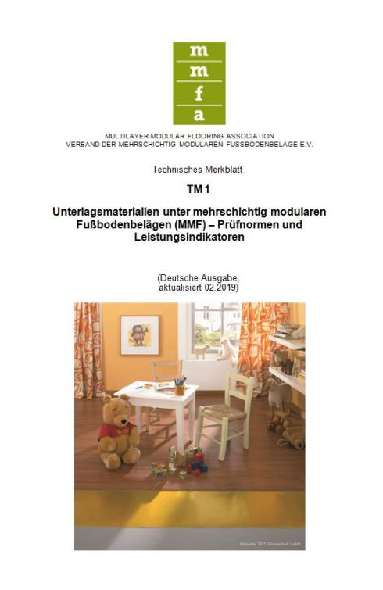
mfne1904_b1:

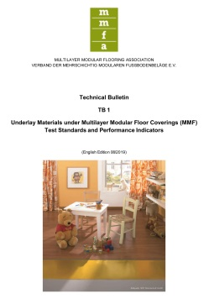

To ensure that a multilayer floor system is able to give top performance in the long term, it is important to use the correct underlay material. The MMFA provides practical information on this subject in its revised Technical Bulletin “Underlay Materials under Multilayer Modular Floor Coverings (MMF) – Test Standards and Performance Indicators, edition 08/2019” – Graphic: MMFA

