European MMFA welcomes IVC Group as a new member

The IVC Group, headquartered in Avelgem (Belgium), has become a member of the MMFA (Multilayer Modular Flooring Association, Bielefeld), effective retroactively from 1st January 2019.

The IVC Group was founded in 1997 and, according to its own statement, is the leading European manufacturer of luxury vinyl tiles (LVT) and also produces sheet vinyl and carpet tiles. With 1,600 employees and ten production sites in Belgium, Luxembourg, Russia and the USA, the IVC Group produces over 180 million m² of flooring per year. In 2015, IVC became part of the US-based Mohawk Industries Inc., the world’s market leader in flooring.

Matthias Windmöller (Windmöller GmbH, Augustdorf), president of the MMFA, is delighted to welcome them on board: “With IVC as a member, we have gained another leading player in our sector. Membership of the MMFA, as our fellow members are aware, means getting involved. There is a lot to be done: various research projects in technical and marketing areas, completing our reflection of market trends via statistics provided by association members, participation in European and international standards. We always welcome additional expertise and an increased ability to be influential!”

Ivo Schintz, president of IVC Commercial Flooring, commented: “As a leader and innovator in LVT flooring, we are excited to join the ambitious MMFA network. Modular multilayer flooring is a dynamic market. It’s our mission to bring innovation to safe flooring systems and share our knowledge in order to reduce climate impact. The professional MMFA platform can help make that happen.”

With the addition of the IVC Group, the MMFA now has 25 ordinary members (producers of MMF flooring or their European representations), 26 associate members (supplier companies) and two supporting members (scientific institutes). Further applications for membership are in the pipeline.

www.mmfa.eu

mfnd1905_pr_b1
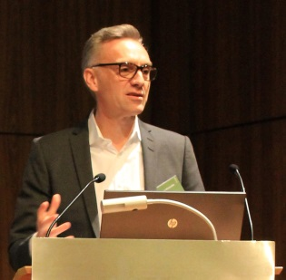
Matthias Windmöller (Windmöller GmbH, Augustdorf), president of the MMFA – Photo: MMFA

mfnd1905_pr_b2
Ivo Schintz, president of IVC Commercial Flooring – Photo: IVC

