MMFA extends languages offered on website
www.mmfa.eu now also available in French

Last year the MMFA e.V. – the Multilayer Modular Flooring Association – upgraded its website www.mmfa.eu, giving it a modern, new look and making it mobile-friendly. Now the website has become trilingual: With immediate effect, the wealth of information on multilayer flooring can now be called up in French as well as the two previous languages German and English. This also applies to the free of charge Technical Bulletins issued by the MMFA.

The MMFA wants to make the information offered on its website accessible to a wider specialist community in France and the Benelux countries, so the plan for next year is to add Dutch as a fourth language.
The website www.mmfa.eu has a comprehensive ‘Products’ section which gives fundamental information on the definitions of MMF floor coverings and their properties and it also shows examples of product structures for the different MMFA product classes. In addition, this section deals in depth with the specific topics ‘Underlays’, ‘Installation’ and ‘Cleaning & Care’. Reports on the findings of MMFA research projects can be found here under the headings ‘Locking strength’ and ‘Temperature resistance’. The ‘Download’ section is where MMFA Technical Bulletins can be downloaded free of charge. Anyone wishing to know more can communicate directly with the experts at the MMFA by filling in the contact form.

Another area of interest is the worldwide sales trend for producers in the association: clicking on ‘Statistics’ takes site users to the MMFA sales figures which are published annually. General information on the structure of the MMFA and its main aims and tasks is given under the ‘Association’ tab, while all ordinary, associate and supporting members are listed in the ‘Members’ section. Information on the current work of the MMFA can be found in the ‘Press’ section, where the association’s press releases (including images) are available for direct download. www.mmfa.eu

Images
mfnd1805_b1:
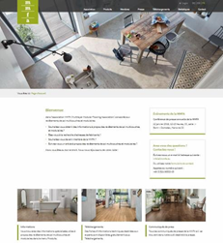
The MMFA website www.mmfa.eu is now trilingual: with immediate effect, all information is now offered in German, English and French. – Graphic: MMFA

