NEW: MMFA Product Classes – Update 1/2018
Agreement on product clusters to be covered by the MMFA (as defined during the joint MMFA Market Development & Technical Committees’ session in Düsseldorf, November 16, 2017:
Multilayer modular floorings for floating installation…
Class 1: All products with wood-based substrates (≥ 65 % content of wood particles/fibres in the core) with polymer or cork surface layer (cork thickness less than 2.5 mm).
Class 2: Polymer or polymer-composite substrate with polymer surface layer and/or lacquer.
Two sub-classes:
Class 2A: LVT click (EN10582) – hot pressed and/or calendered.
Class 2B: all other polymer substrates (EN 16511) – EPC and SPC.
(EPC: expanded polymer core, SPC: solid polymer core).
Class 3: All products not covered by class 1 or 2, or external standards.
Note: Class 3, for example, covers modules using a click system and textile surface or those on a mineral core.

MMFA Class 1: Exemplary product structures

Class 1: All products with wood-based substrates (≥ 65 % content of wood particles/fibres in the core) with polymer or cork surface layer (cork thickness less than 2.5 mm).

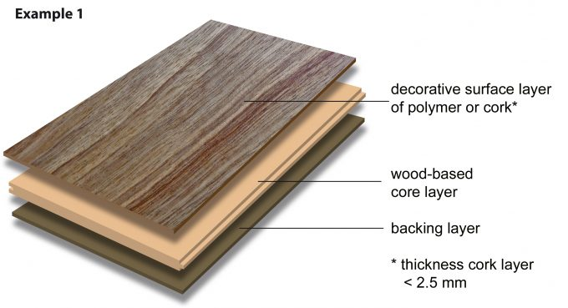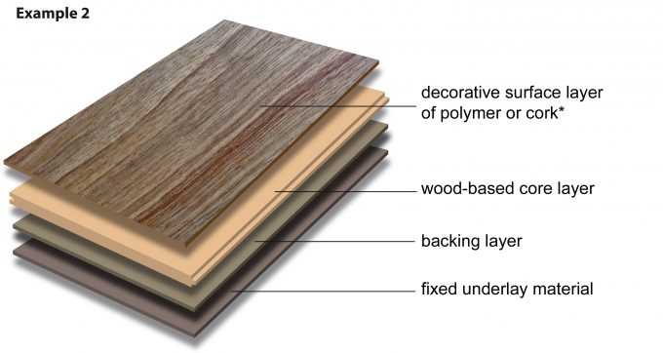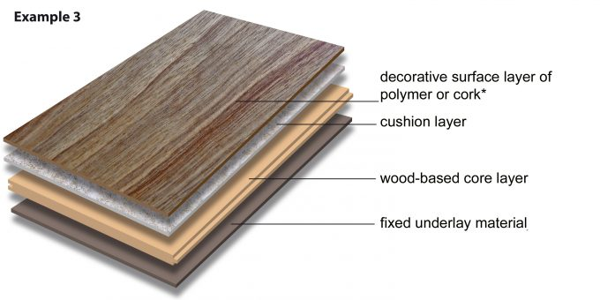

MMFA Class 2A: Exemplary product structures

Class 2: Polymer or polymer-composite substrate with polymer surface layer and/or lacquer.
Sub-class:
Class 2A: LVT click (EN10582 and EN 16511) – hot pressed and/or calendered.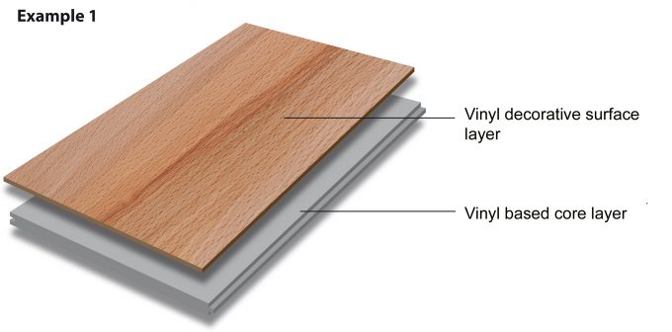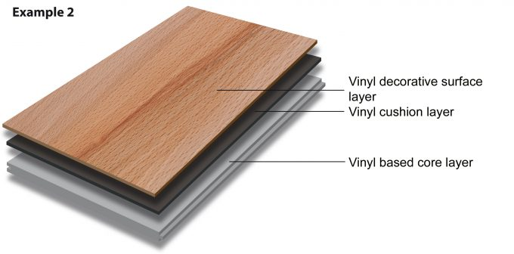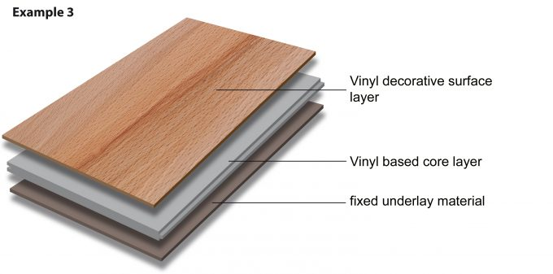

MMFA Class 2B: Exemplary product structures

Class 2: Polymer or polymer-composite substrate with polymer surface layer and/or lacquer.

Sub-class:
Class 2B: all other polymer substrates (EPC and SPC).
(EPC: expanded polymer core and SPC: solid polymer core)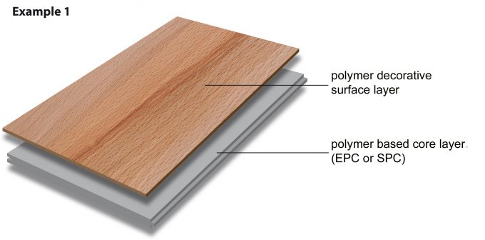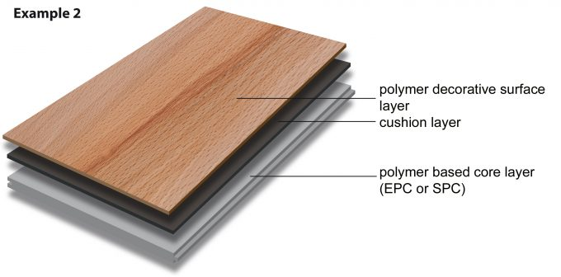

MMFA Class 3: Exemplary product structures

Class 3: All products not covered by class 1 or 2, or external standards.

Note: Class 3, for example, covers modules using a click system and textile surface or those on a mineral core.