New flooring products under one umbrella

Flooring producers establish new European Association MMFA

Ten European flooring producers gathered in Munich on October 26 to launch a new association: the MMFA – Multilayer Modular Flooring Association. The final trigger were the increasing sales volumes of multilayer floorings with various surfaces such as LVT, cork, PU or PET – or a bit more objective under the standard name „multilayer semi-rigid floorcoverings“. All multilayer products which have not found a home yet with the existing associations, will now get the opportunity to have their interests represented under the new MMFA umbrella. The MMFA will advocate technical features such as product standardization and nomenclature, but also product information and promotion. Last but not least it will promote the idea of sustainability in the sector. The sphere of activities will cover all of Europe.

The stimulus for the launch came from the sector itself. More and more often flooring products are developed and introduced to the market, which are multilayer products by construction and composition and therefore do not fall into the existing categories of either laminate or elastic flooring. That is why the producers saw the need for launching a proper European association in order to represent their specific interests.

First board appointed unanimously

Moderated by Peter H. Meyer, long-term managing director of the EPLF – European Producers of Laminate Flooring (Bielefeld/Germany), there had been several preliminary talks and preparation works since autumn 2011. This successful groundwork led to the inaugural meeting on October 26 in Munich. Chaired by Meyer and in the presence of Hans Joachim Schilgen, managing director of the trade association of the producers of elastic flooring [FEB – Fachverband der elastischen Bodenbelagshersteller e. V.], the founder members unanimously enacted the statutes of the MMFA. After registration with the German authorities the association’s name will bear the affix “e. V.” (registered association). The business location of the MMFA will be Bielefeld/Germany.

The board was equally elected unanimously: Matthias Windmöller (Witex Flooring Products GmbH, Augustdorf/Germany) made himself available as the first chairman of the board, first vice chairman is Edwin Lingg (Li & Co AG, Müstair/Switzerland), appointed as a further member of the board was Volker Kettler (MeisterWerke Schulte GmbH, Rüthen-Meiste). Financial controlling lies in the safe keeping of Dr. Peter Hamberger (Hamberger Flooring GmbH & Co. KG, Stephanskirchen). All seven founding members of the new association manufacture and market the new floorings themselves: akzenta Paneele + Profile GmbH (Kaisersesch), Hamberger Flooring GmbH & Co. KG (Stephanskirchen), Li & Co AG (Müstair/Switzerland), MeisterWerke Schulte GmbH (Rüthen-Meiste), Parador GmbH & Co. KG (Coesfeld), Skema S.r.l. (Ponte di Piave, Treviso/Italy) and Witex Flooring Products GmbH (Augustdorf).

Standardization and comprehensive information for the market

The board expects that the other three producers attending the inaugural meeting will also join the MMFA shortly. All other interested parties are just as welcome: producers as full members, and suppliers or institutes etc. as associate members.

The new chairman Matthias Windmöller explains the objectives: “The foundation of the MMFA is an important step for a successful market development of innovative flooring products in Europe. All producing companies which as a basic requirement mechanically process the flooring elements mainly by themselves can become full members. All other stakeholders are cordially invited to cooperate as associate members. For our products we expect an expansive market development and hence a positive membership trend. Now we are full of vim and vigor to get started on our main spheres of work at the MMFA.”

First and foremost, the activity of the association focuses on the technical structure and standardization, the elaboration of differentiated product definitions and -terms, standards for product claims, as well as the horizontal cooperation with related associations and legal or regulating bodies of the sector. Another necessary field of activity will be the comprehensive information and consulting for the trade and the consumers. The aim is to successfully establish the new modular multilayer flooring products as a unique category in the market, next to cork floorings, parquet, laminate or elastic flooring.
A plead for sustainability

Windmöller adds: “The MMFA and its members are clearly commited to promote the idea of sustainability in the industry.“ The board will come together again in early November for a statutory meeting. In time for the first annual general meeting in early June 2013 the main course will be set and important tasks will be well processed.

Figures
mfne1201_b1:
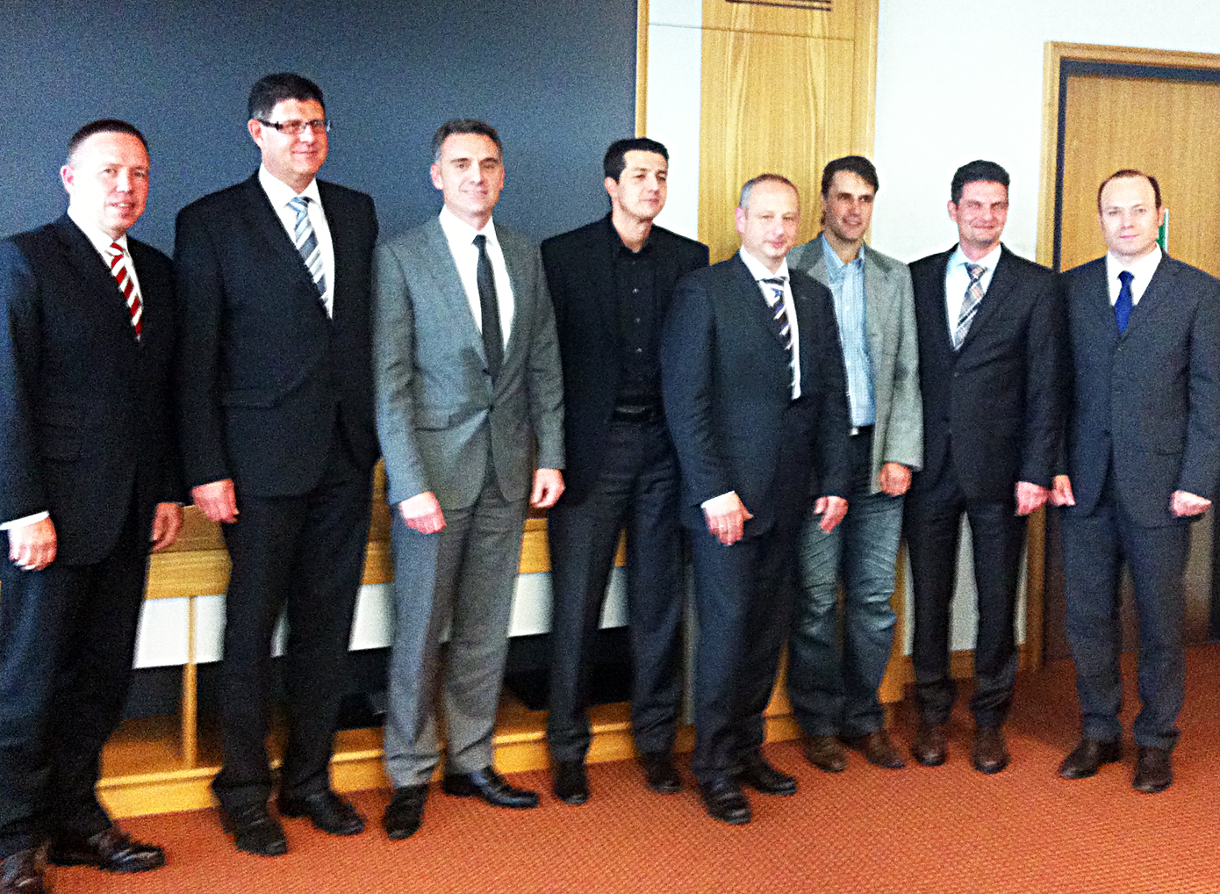
Seven flooring producers launched the MMFA in Munich on October 26 (l. to. r.): Volkmar Halbe (Parador GmbH & Co. KG, Coesfeld/Germany), Ludger Schindler (MeisterWerke Schulte GmbH, Rüthen-Meiste), Matthias Windmöller (Witex Flooring Products GmbH, Augustdorf), Sebastian Wendel (akzenta Paneele + Profile GmbH, Kaisersesch), Volker Kettler (MeisterWerke Schulte GmbH, Rüthen-Meiste), Edwin Lingg (Li & Co AG, Müstair/Switzerland), Dr. Peter Hamberger (Hamberger Flooring GmbH & Co. KG, Stephanskirchen), Nicola De Menis (Skema S.r.l., Ponte di Piave, Treviso/Italy). – Photo: MMFA

mfne1201_b2:
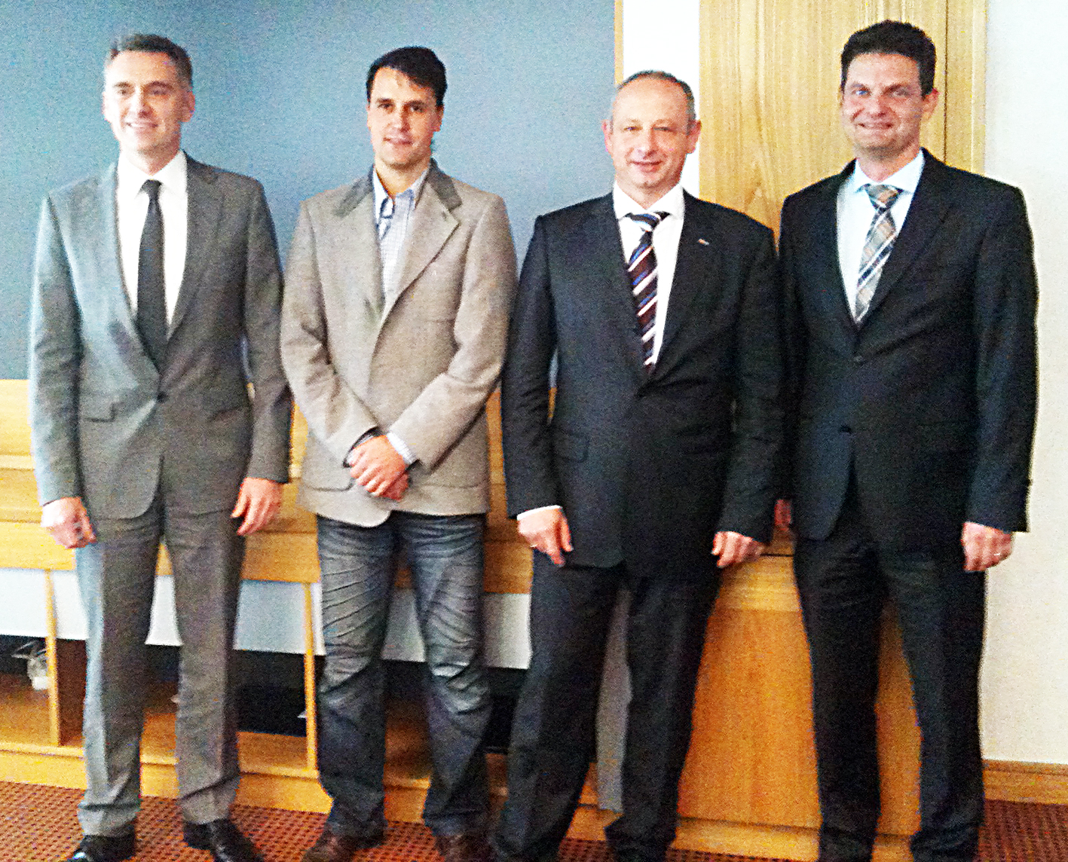
The board of the MMFA was appointed unanimously (l.to .r.): Chairman Matthias Windmöller (Witex Flooring Products GmbH, Augustdorf/Germany) and vice chairman Edwin Lingg (Li & Co AG, Müstair/Switzerland), member of the board Kettler (MeisterWerke Schulte GmbH, Rüthen-Meiste), financial controlling Dr. Peter Hamberger (Hamberger Flooring GmbH & Co. KG, Stephanskirchen). – Photo: MMFA

